Non-parametric tests:
Chi Square, Fisher exact,
Mann-Whitney rank-sum.

Comparing groups with binary outcomes
- Let us assume that we have two patient groups we need to compare: one that received treatment and one that received placebo.
The measure of an outcome is if patient’s tumor decreased in size
- We want to test if treatment really had an effect

Let us assume the following 2x2 contingency table
 | Tumor reduction | No change
Treatment | 82 | 18
Placebo | 60 | 140
Note these cells are NOT overlapping

Question
- Did this treatment have an effect?
 | Tumor reduction | No change
Treatment | 82 | 18
Placebo | 60 | 140
100
200
142 158
Total = 300
What would be EXPECTED if the treatment had no effect?
- Out of 300 patients, we have 142 (47%) with tumor reduction and 158 (53%) whose tumors did not change
- If the treatment had NO effect, we would EXPECT 47.33% of people of who were treated to have tumor reduction and 52.67% of people who were treated to have the same tumor (no reduction)

Table of actual values
 | Tumor reduction | No change
Treatment | 82 | 18
Placebo | 60 | 140
100
200
142 158
Total = 300
47.3% 52.67%

Table of expected values (if treatment has NO effect)
 | Tumor reduction | No change
Treatment | 47.33 (47.3%) | 52.67 (52.67%)
Placebo | 94.67 (47.3%) | 105.33 (52.67%)
100
200
142 158
Total = 300

We will now define a statistics that reflects how much the observed variables in each cell in the table differ from the variables we would expect if the treatment has no effect.
- This statistics is called chi squared (χ²)
χ ² = Sum of (Observed – Expected in each cell)² Expected in each cell
- The equivalent mathematical statement is
χ each cell)
E
Let us compute χ ² for our data
χ 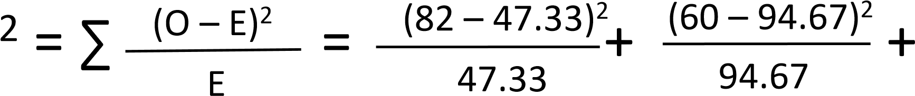
(18 – 52.67)² (140 – 105.33)²
+ _{52.67} + _{105.33} = 72.312

- What will happen if observed frequencies are similar to the expected frequencies?
Answer: the numerator will be small and thus χ ² will be small
- χ ² follows χ ² distribution
- Degree of freedom for this distribution depends on the number of treatments being compared and the number of possible outcomes.
- In our case, there are 2 treatments (treatment and placebo) and 2 possible outcomes (tumor reduction or no change)
df = (# of rows -1)*(# or columns -1) = (2-1)*(2-1) = 1

χ ² distribution with df =1
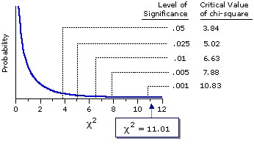
Similar to normal and t-distributions, there are tables where you can look up χ ² value and corresponding area under the curve

χ ² distribution with df =1
Our χ ² is 72.3 and we can say with certainty that this treatment has an effect as its p<0.001(note we are testing only the right tail here)

PE1
• Assume that we have two distinct non-overlapping patient populations: 200 people that received Drug1 and 300 people that received Drug2. 80% of the people that received Drug1 and 75% of people that received Drug 2 experienced tumor reduction. Is the effect of Drug1 significantly different from the effect of Drug2?

Fisher exact test
- Fisher exact test should be used over Chi Squared test if the expected frequency is less than 5 in at least one of the cells in the contingency table.
- Otherwise, these tests give comparable results
- Fisher exact test basically computes all probabilities associated with possible arrangements of the data

Let us consider the same table
 | Tumor reduction | No change
Treatment | 82 | 18
Placebo | 60 | 140
100
200
142 158
Total = 300

Let us consider the same table
 | Tumor reduction | No change
Treatment | a | c
Placebo | b | d
a+c b+d
Total = n = a+b+c+d
Note that a, b, c, and d and NOT overlapping
Probability of having exactly this outcome (we use combination here)
 | Tumor reduction | No change
Treatment | a | b
Placebo | c | d
a+b c+d
a+c
Total = n = a+b+c+d

Probability of having this outcome (we use combination here)
 | Tumor reduction | No change
Treatment | a | b
Placebo | c | d
a+b c+d
a+c
Total = n = a+b+c+d
Number of ways to choose this possible outcome (a from a+b and c from c+d)
a+b
a
c+d
c
n
_{a+c} Number of ways to choose all possible outcomes to get a+c
patients with tumor reduction from a+b+c+d total patients
Note….
P = =
a+b
a
c+d
c
n
a+c
a+b
b
c+d
d
n
b+d

this outcome
 | Tumor reduction | No change
Treatment | 82 | 18
Placebo | 60 | 140
100
200
142 158
Total = 300
100 200
82 60
300 142

this outcome
 | Tumor reduction | No change
Treatment | 82 | 18
Placebo | 60 | 140
100
200
142 158
Total = 300

this outcome
 | Tumor reduction | No change
Treatment | 82 | 18
Placebo | 60 | 140
100
200
142 158
Total = 300
100 200
82 60
= 3.5e-18 (very significant)
300 142
- Please note that we stopped at calculating probability of the exact outcome (as depicted in the
2x2 contingency table)
- Calculating probabilities of getting patterns in the data this extreme or more extreme were not covered in this lecture.

PE2
• Consider two patient groups from PE 1. Use Fisher exact approach to calculate P (probability of getting exactly this table).

Mann-Whitney rank-sum test
- This test is similar to t-test, but does not have any assumptions of normality and is based on the ranks of the observations
- Let us assume these two groups of patients: one that received a diuretic treatment and one that received placebo

Two groups of patients
Daily urine production
Placebo (group 1)
1000
1380
1200
Drug (group 2)
1400
1600
1180
1220

Let us calculate their ranks
Daily urine production | Ranks
Placebo (group 1)
1000 | 1
1380 | 5
1200 | 3
Drug (group 2)
1400 | 6
1600 | 7
1180 | 2
1220 | 4
p.s. tied observations would be assigned the same rank (equal to the average of the ranks they would be assigned to without ties)

Let us calculate their ranks
Daily urine production
Placebo (group 1)
1000 | 1
1380 | 5
1200 | 3
Drug (group 2)
1400 | 6
1600 | 7
1180 | 2
1220 | 4
If treatment had an effect, we would expect rankings of the Placebo group to be lower, compared to the treatment group

Let us calculate the rank-sum
Daily urine production
Placebo (group 1)
1000 | 1
1380 | 5
1200 | 3
Drug (group 2)
1400 | 6
1600 | 7
1180 | 2
1220 | 4
Sum of the ranks in group 1 is 1+5+3=9
How extreme is this rank-sum?
- How likely is it to get a rank-sun of 9?
- We need to evaluate all possible rankings of the 7 observations, divided into two groups (one with 3 and one with 4 individuals) to see how likely it is to get a rank-sum of “9” in the group of 3 observations.
Step 1: In how many ways can we choose a group of size 3 out of 7 patients?
- (7 choose 3) = 7!/(3!*4!)=
(7*6*5*4*3*2*1)/(3*2*1*4*3*2*1)
=(7*6*5)/(3*2)=7*5=35
There are 35 different ways to choose a group of size 3 out of 7 patients

Step 2: Let us start building an outcome table…
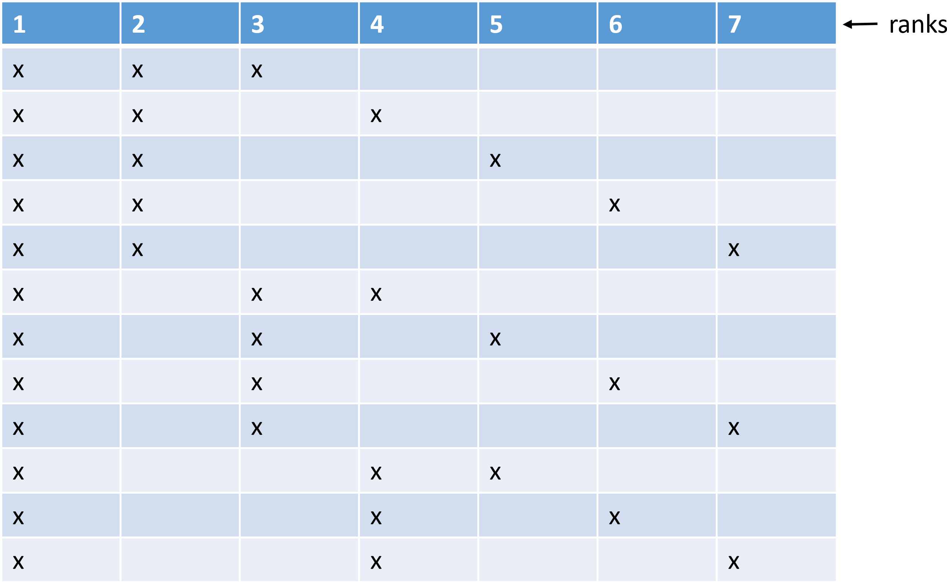
X corresponds to ranks of values inside the group of size 3. The table goes on (to 35 rows)

Step 3: We can calculate rank-sum _{ranks} for each row
1 | 2 | 3 | 4 | 5 | 6 | 7 | Ranksum
x | x | x |  |  |  |  | 6
x | x |  | x |  |  |  | 7
x | x |  |  | x |  |  | 8
x | x |  |  |  | x |  | 9
x | x |  |  |  |  | x | 10
x |  | x | x |  |  |  | 8
x |  | x |  | x |  |  | 9
x |  | x |  |  | x |  | 10
x |  | x |  |  |  | x | 11
x |  |  | x | x |  |  | 10
x |  |  | x |  | x |  | 11
x |  |  | x |  |  | x | 12
The table goes on (to 35 rows)

Step 4: We can now use these ranksums to build rank-sum distribution… (using the data on the previous slide)

If we use all 35 rows, we will get this distribution

What are the chances of getting 18 as a sum?
1/35
What are the chances of getting 9 as a sum?
3/35

What are extreme values of this rank-sum distribution (5% tails)?
1/35 = 0.029= 1/35 = 0.029=
2.9% 2.9%

What are extreme values of this rank-sum distribution (5% tails)?
1/35 = 0.029= 1/35 = 0.029=
2.9
%
2.9
%
6 7 8 9 10 11 12 13 14 15 16 17 18
Rank –sum values
We can assume that values of 6 and 18 enclose most extreme values, which approximate “95% confidence interval”
How is run-sum “9”?
1/35 = 0.029= 1/35 = 0.029=
2.9
%
2.9
%
6 7 8 9 10 11 12 13 14 15 16 17 18
Rank –sum values
“9” is not in the tails, and thus the difference between the groups is not significant
Step 5: In general, consult a MannWhitney rank-sum statistic table to find your p
Table example
# Group 1 | # Group 2 | Critical val left | Critical val right | P (approximates 0.5)
3 | 4 | 6 | 18 | 0.057
3 | 5 | 7 | 20 | 0.071
3 | 6 | 7 | 23 | 0.048
3 | 7 | 8 | 25 | 0.067
3 | 8 | 8 | 28 | 0.042

As sample size gets larger
• Interestingly, as sample size gets larger (n=8) , the rank-sum distribution approximates normal distribution

PE3
• Assume the following two groups
Daily urine production
Placebo (group 1)
900
1390
1200
Drug (group 2)
1400
1600
1180
1230
Is the difference between groups significant? (non-parametric assumption)

HW
Please do practice exercises by Tuesday Nov 6th. I will post solution on Wednesday Nov 7th.
Reading for the next class: Chapter 8 (optional)

